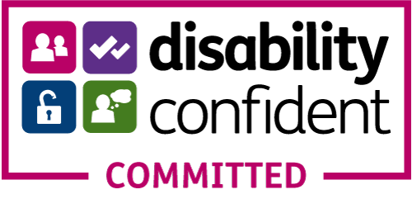
Equal Opportunities Monitoring Form

We are committed to equal opportunities in our recruitment process and in order to find out how well we are doing with this we need to collect monitoring data. Although this monitoring form is voluntary, the information provided helps us greatly. The information you supply on this form will be kept confidential. The monitoring form is not used in the shortlisting or interview process.

How did you find out about this post?

Our website
Online publication/job-board (please state):
Printed publication (please state):
Agency (please state):
Mind networks (please state):
Social media (please state):
Other (please state):

Ethnic Origin

These categories are based on the Census 2011 categories and recommended by the Commission for Racial Equality.
Asian, Asian British, Asian English, Asian Scottish, or Asian Welsh  Asian / Asian British  Bangladeshi  Chinese  Indian  Pakistani  Other Asian background (specify if you wish): | White  British  English  Gypsy or Irish Traveller  Irish  Scottish  Welsh  Other White background (specify if you wish):
Black, Black British, Black English, Black Scottish, or Black Welsh  African  Caribbean  Other Black background (specify if you wish): | Mixed  White and Asian  White and Black African  White and Black Caribbean  White and Chinese  Other mixed background (specify if you wish):
Other ethnic group  Arab  Other ethnic group | Prefer not to say
Your gender

Male Female Prefer not to say

Have you ever identified as transgender?

Yes No

Your age

Date of Birth:

16 - 24 25 - 34 35 - 44 45 - 54 55 - 64 65+

Prefer not to say

Your sexual orientation

Bisexual
Gay man
Gay woman/lesbian
Heterosexual/straight
Other (specify if you wish):
Prefer not to say

Marriage and civil partnership

Single
Married/in a registered same-sex civil partnership
Separated, but still legally married/in a registered same-sex civil partnership
Divorced/formerly in a same-sex civil partnership which is now legally dissolved
Widowed/Surviving partner from a same-sex civil partnership
Prefer not to say

Your religion or belief
No religion  Buddhist  Christian (including Church of England, Catholic, Protestant and all other Christian denominations)  Hindu | Jewish  Muslim  Sikh  Other (specify if you wish):  Prefer not to say

Your experience of mental health problems
Would you describe yourself as someone who is experiencing or has experienced mental health problems?

Yes.
Please state how Mind can support you in your employment:
No
Prefer not to say

Disability

The Equality Act 2010 defines a disabled person as someone who has a physical or mental impairment which has a substantial and long-term adverse effect on their ability to carry out normal day-to-day activities.

Do you consider yourself to be disabled?

Yes.
Please specify:
No
Prefer not to say

Please return to: email recruitment@mindinbradford.org.uk or by post
Mind In Bradford, Kenburgh House, 28 Manor Row, Bradford, BD1 4QU

