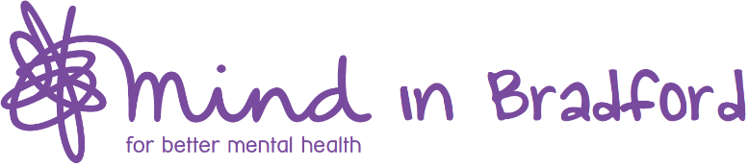

Privacy Notice for Children & Young People

This privacy notice is about the personal information we collect and process about you. It explains why we need it, what types of information we need, who we might share it with, how we keep it secure and what your rights are.

We require your consent to process your personal information; by providing us with your personal information and agreeing to this privacy notice, you are giving us that consent. If you do not consent, we cannot provide you with the service requested.

Who we are
Mind in Bradford is a mental health charity supporting children, young people and adults across Bradford District and Craven. The majority of our funding comes from the NHS and Council.

Why we collect information about you and how we use it
We collect your personal information so we can provide you with safe and effective support. We only collect information that we need to know in order to provide and improve our services, promote your welfare, keep you and others safe from harm and ensure we meet our legal duties.

What data we process and how long we keep it
The personal information we collect about you includes, but is not limited to:
- your name, date of birth, contact information and NHS number
- your parent/legal guardian’s name and contact information
- details of your mental and physical health and the areas of your life you want support with
- information about your ongoing support including case notes, plans and reviews
- your gender identity, ethnicity, religion, sexuality and disabilities

As we need to collect information about your parent/guardian they will also need to sign a privacy notice, giving us their consent. For more information about this, please ask a member of staff.

We are legally required to hold your information for a set period of time. We will not keep it longer than required or permitted by law. Full details about this are in our Data Protection Policy.

Sharing your data
We may need to share information about you with other people or organisations involved in your life, for example, your parent/guardian, social services, school, youth service, youth offending team, police, NHS services and other organisations providing you with support.

When information sharing is required, staff will explain to you fully what data needs to be shared, why, and with whom. Your data will only be shared against your wishes when it is in your vital interests or if we have legitimate concerns for the wellbeing or safety of you or others. We take your privacy very seriously and will never share your personal data with anyone who does not have a lawful and/or administrative purpose for using it. More information about this can be found in our Confidentiality Policy. Please ask a member of staff if you would like a copy.

How we keep your data safe
The information we process about you is held securely in paper and digital formats. We mainly record and store your data on our two secure digital platforms; MYMUP and Mind in Bradford’s Virtual Private Network. These platforms can only be accessed by Mind in Braford employees.

In some circumstances, we may need to record your data in paper format. All paper recordings are held securely in locked cabinets, within locked offices that are only accessible by employees.
Your rights
You have the right to ask us to keep your data accurate and up-to-date. If any of your personal data changes, or you think we are holding data that is incorrect, please tell a member of staff.

You have the right to see a copy of the personal data we hold about you. We will provide the requested data within one month of your request.
You have the right to withdraw your consent. We will remove any personal data concerning you within one month of you withdrawing consent, unless we have a legal duty to retain it. We will tell you if this is the case.
If you would like to exercise any of these rights, you can speak to a member of staff, email us at admin@mindinbradford.org.uk, write to us at Helen Davey, Mind in Bradford, Kenburgh House, 28 Manor Row, Bradford, BD1 4QU or phone us on 01274 730815.
You also have the right to lodge a complaint with the Information Commissioner’s Office if you have any concerns about the way we are using your personal information. More information can be found at their website, https://ico.org.uk/concerns/ or by calling their helpline 0303 123 1113.

Please read, sign and date the declaration below:

I agree with the conditions of this privacy notice and give consent for Mind in Bradford to
collect and process my personal information in line with this privacy notice:

Print Name:

Signature: Date:

If you would like a copy of this Privacy Notice, please tick this box:

