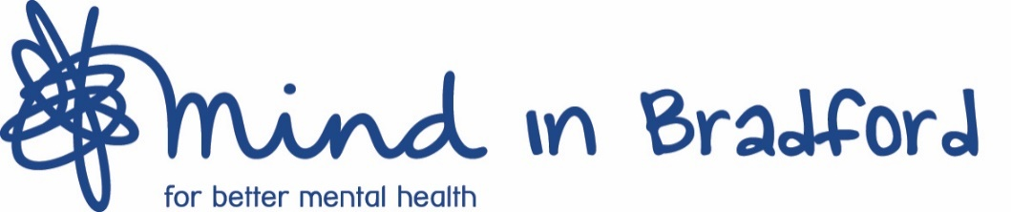

Post: Recovery Worker, Sanctuary service
Hours: 21 hours per week, shifts will mostly be 18:00 – 01:00. Fixed term until 31st March 2022.
Salary: £11.87 per hour
Location: Kenburgh House, 28 Manor Row, BD1 4QU.
Responsible to: Service Manager
Pension: We operate a contributory pension scheme which you will be auto-enrolled into (subject to the conditions of the scheme).
Probationary Period: 6 months

Purpose of the post

This role is to work within the evening on our Sanctuary Crisis Support Service. The Sanctuary service is an evening offer as part of the district’s Safe Spaces initiative. Clients are referred by the First Response crisis support line as an alternative to visiting A&E.
You will work as part of a team of committed mental health practitioners who offer mostly one-to-one crisis support to clients attending pre-booked appointments at our city centre head office, Kenburgh House. This is a 365-day-a-year service which is offered from 5pm-1am.
We envisage the working hours of the role we are advertising mainly being 6pm – 1am. The working pattern will 21 hours per week, but we expect that the specific evenings worked may vary from week to week and this role is likely to include some weekend work. We will endeavor to agree the shifts worked each week at least one month in advance with the successful candidate.

Key duties

- To provide a safe space and emotional support via face to face and telephone support to those attending the Sanctuary service that may be experiencing a mental health crisis.
- To signpost to relevant services for additional support where necessary.
- To record accurate information electronically and maintain up to date records via our recording systems.
- To work effectively within a team and to support other co-workers on shift.
- Ensure that the rights of people with mental health issues are respected and promoted throughout the organisation in accordance with our values
- Work in partnership with other services across Bradford District and Craven to ensure the best outcome for clients.
- Accept and work within the organisations policies and procedures and assist in promoting the organisations aims and objectives.
- Have an understanding of and commitment to equal opportunities and diversity.
- Commit to training and self-development and to undertake any training required to carry out the duties of the post.
- Promote all aspects of the services and enhance the public image of Mind in Bradford.
- Be familiar with the Mind in Bradford ‘Code of Conduct’ and ensure it is followed by staff, volunteers and clients.
- Undertake any other reasonable duties as required to ensure the smooth running of Mind in Bradford.

Our organisation
Mind in Bradford is a registered charity with a clear purpose to promote positive mental wellbeing and empower and help people experiencing mental health problems to manage and work towards recovery and fulfilment. We do this through:

- Building community and individual resilience for better mental wellbeing
- Providing early intervention advice and support
- Supporting people in crisis
- Empowering and helping people to recover and sustain improved wellbeing.

Our values
Our team is committed to five values which underpin everything we do:

- Caring always
- Working together
- Supporting everyone
- Enabling all
- Improving continually

Person Specification
 | Essential | Desirable
Qualifications | - A minimum of 5 GCSE’s (or equivalent) grades A-C (must include English)  - Evidence of ongoing professional development | - A degree in an area related to mental health or equivalent  - A diploma in psychotherapy, counselling, coaching or other professional interventions  - An NVQ Level 3 qualification or above in mental health or similar
Experience | - Experience of working in a mental health setting with adults or young adults who have or have had mental health challenges  - Experience of supporting vulnerable clients in a clear, meaningful and non-judgmental way  - Confident in managing challenging situations  - Excellent IT Skills, including use of Microsoft Packages and online recording systems | - Experience of supporting clients via telephone  - Experience of using a recording system
Skills and Abilities | - Excellent proven communication and organisational skills  - Ability to work as part of a team and work alone and use own initiative  - Ability to encourage, engage and involve people in ways that promote their contribution, independence, resilience and achieve positive changes in their lives | - Car driver with full UK driving licence and access to own transport  - Recently completed Safeguarding training
Knowledge | - Understanding of current issues faced by people with mental health issues  - Knowledge of other organisations and charities in the area that can support our clients  - An understanding of the effectiveness of talking therapies and telephone support services  - Knowledge and understanding of risk management and health and safety issues  - Understanding of Safeguarding and good practice | - General knowledge of mental health and wellbeing through lived experience  - Understanding of confidentiality and data protection
Attitude and Personal Attributes | - Understanding of and commitment to equal opportunities and diversity.  - Commitment to providing person centred services.  - Understanding that mental health difficulties are a natural part of life.  - Healthy and secure personal boundaries  - Understanding of and commitment to the Mind in Bradford values of Partnership, Inclusivity, Empowerment, Excellence and Responsibility.

